Name : ……………… English

English test

The Elephant and the Bad Baby

What is it ?

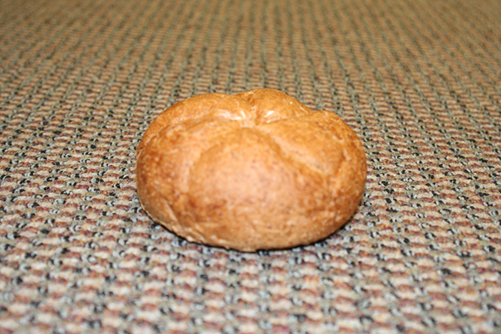 | --------------------------------------------------------
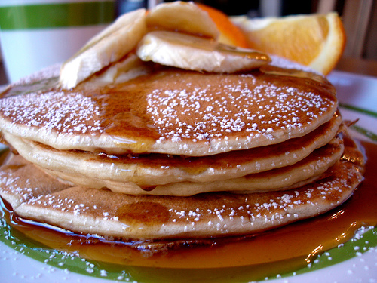 | --------------------------------------------------------
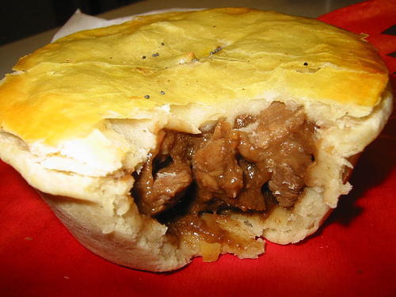 | --------------------------------------------------------
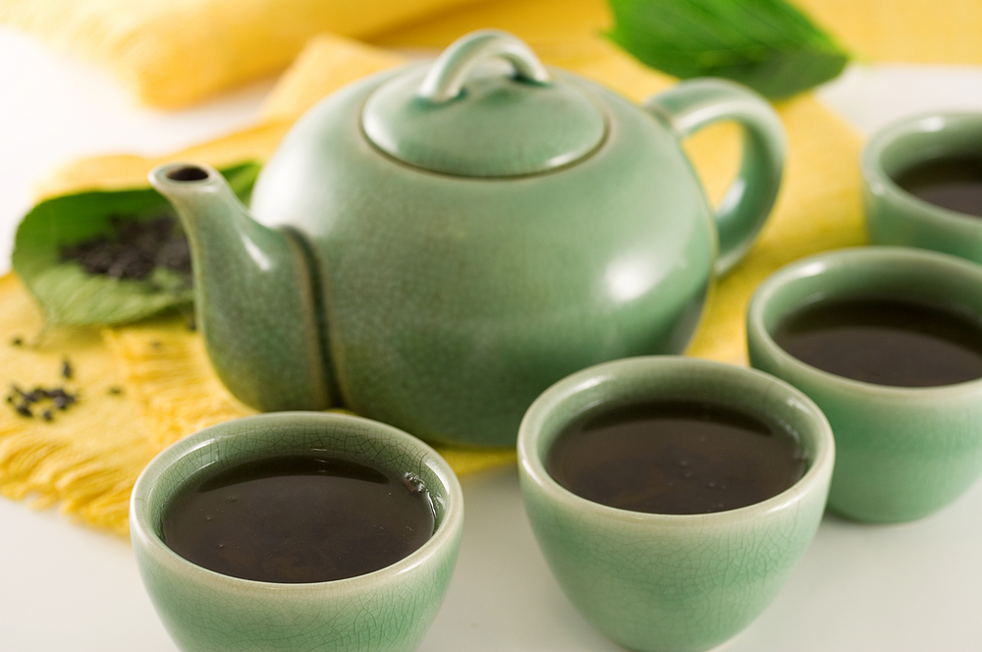 | --------------------------------------------------------
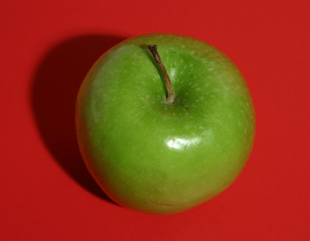 | --------------------------------------------------------
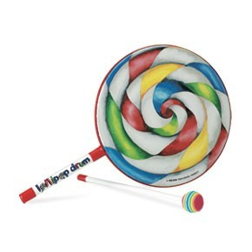 | --------------------------------------------------------
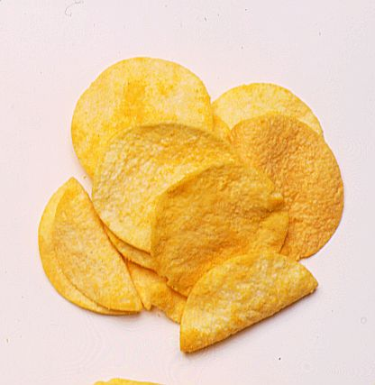 | --------------------------------------------------------
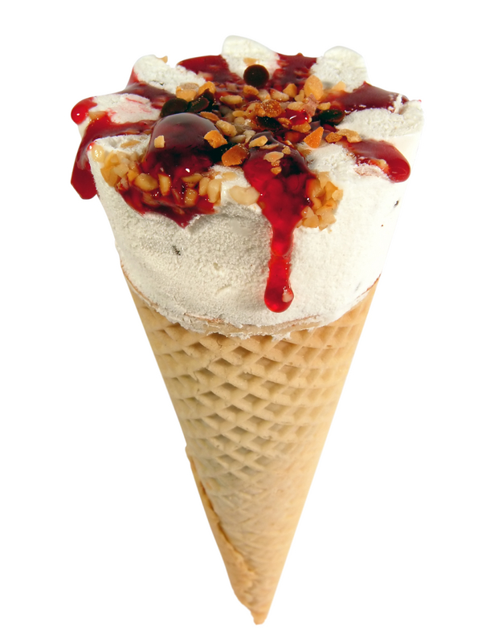 | --------------------------------------------------------
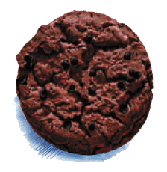 | --------------------------------------------------------

Match the article with the shop:

FOOD | SHOPS
Ice-cream • | • Fruit barrow
Pie • | • Grocer’s shop
Bun • | • Butcher’s shop
Crisps • | • Sweet shop
Chocolate biscuit • | • Baker’s shop
Lollipop • | • Ice-cream stall
Apple • | • Snack bar

Fill in the blanks :

Baker : Good morning, Sir.
Customer : Good morning.
Baker : …………………
Customer : I’d like a bun, please.
Baker : Here you are.
Customer : …………………
Baker : You’re welcome.
Customer : …………………
Baker : 70 pence, please.
Customer : …………………
Baker : Thanks. Have a nice day.
Customer : …………………

