Name : ………………………… English

The elephant and the bad baby

Food and shops

Fill in the blanks with the following words :
at the sweet shop
at the snack bar
at the grocer’s shop
at the fruit barrow ?
at the baker’s shop
apples
biscuits
buns
crisps
lollipops

What’s there at the ice-cream stall?  There’s ice-cream at the ice-cream stall. | 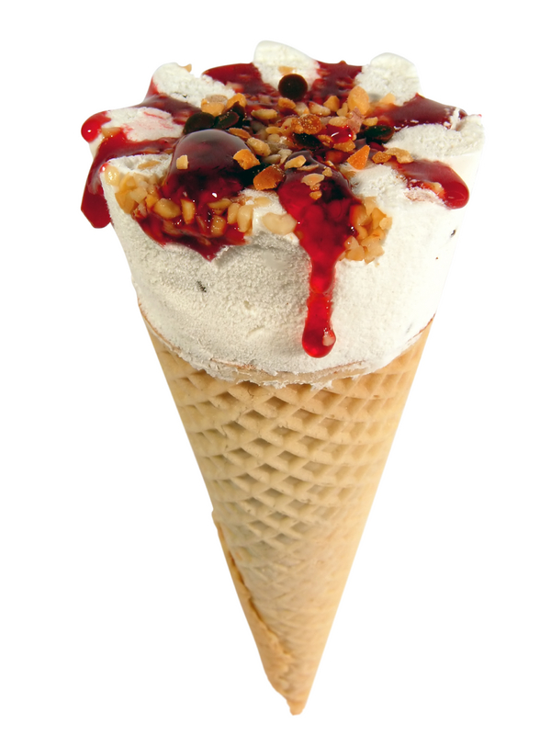
What’s there at the butcher’s shop?  There’s meat at the butcher’s shop.  There’re pies at the butcher’s shop. | 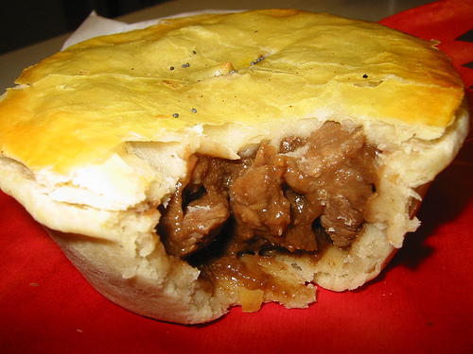
What’s there……………..………….?  There’s bread at the baker’s shop.  There’re cakes at the baker’s shop.  There’re …………... at the baker’s shop. | 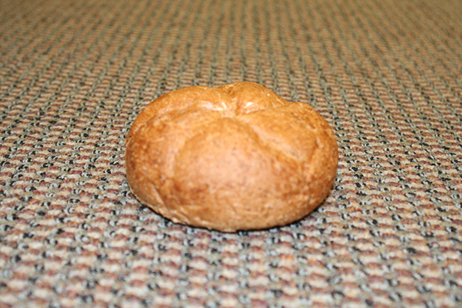
What’s there ………..…………..?  There’re …………... at the snack bar. | 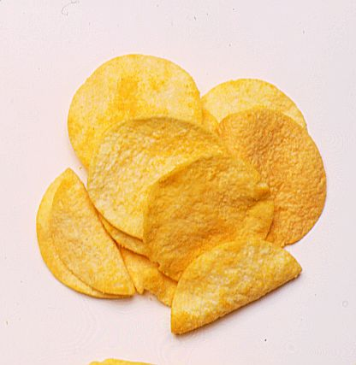
What’s there ……………..……..?  There’re ……………. at the grocer’s shop. | 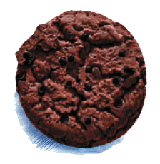
What’s there…………………….?  There’re …………… at the sweet shop. | 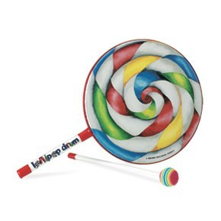
What’s there…………………….?  There’re lemons at the fruit barrow.  There’re oranges at the fruit barrow.  There’re …………… at the fruit barrow. | 